

Outdoor 4G RFID Card Payphone

Model: MX-400(700LR )

USER MANUAL

MaxComm Co.,Ltd

Last Update Time: 2024-6-28

Table of Contents
1. Preface 3
2. Product Overview 4
2.1 Basic Functions & Features 4
2.2 Appearance 4
2.3 Keypad 5
3. Mounting the Phone 6
4. Using the Phone 9
5. Recharging a RFID Card 10
6. Make Call via “Collect-Call” Mode 11
7. Technical Specifications 14
8. After-Sale Service 15

1. Preface
Thank you for purchasing the Outdoor 4G RFID Card Payphone of MaxComm Co., Ltd.
It is recommended that you read the operating instructions and safety precautions in this manual carefully prior to installing and using this product.

Safety Precautions
- Please read this manual thoroughly and keep it safe for future use. Breach of these notes may cause dangers or offending relevant laws.
- The product is designed for outdoor operating. Don’t use it for other purposes.
- Protect the Phone from intense impact and vibration during transporting, installing and using. The Phone may be permanently damaged if excessive force or liquid dunking is applied to the Phone.
- Before using the Phone, relevant instructions should be read thoroughly. Try to operate the Phone in accordance with relative environment condition and operation guide.
- Avoid installing the Phone beside a strong magnetic field or in a dusty environment in order not to reduce the service life.
- If the Phone has failure, please contact the local representative or after service department of our company. Any disposal beyond our authorization will void the warranty clause.

2. Product Overview
This is an outdoor wall-mounted payphone supporting payment with or without RFID cards (Mifare card), by inserting a 4G SIM card inside. Designed with anti-vandalism casing and parts for high performance, it is applicable for airports, scenic spots, streets, schools, factories, armies, and jails, etc.
The Payphone is plug-&-play and easy to install. And the operator can define the call rate and check revenue records via the cloud-based NMS platform.

2.1 Basic Functions & Features
- Support making calls via RFID cards, or making calls to family phone numbers for students/prisoners without RFID cards.
- Provided with function key for recharging RFID cards, or recharging call cost to family phone numbers.
- Complete visual prompts offer a friendly operation instruction.
- Modular design and appropriate layout for convenient maintenance.
- Robust casing and superior sealing give high resistance to dust, water, corroding and vandalism.
- Self-diagnosis and fault prompt.
- Configurable call rate.
- Offer cloud-based Network Management System (NMS) to manage 100,000 sets of Payphone and provide exportable statistics reports.

2.2 Appearance
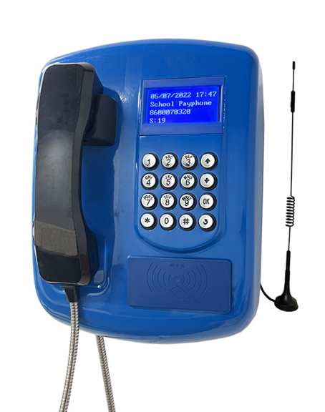
Keypad
LCD
4G Antenna
RFID Card Reader
Handset

2.3 Keypad
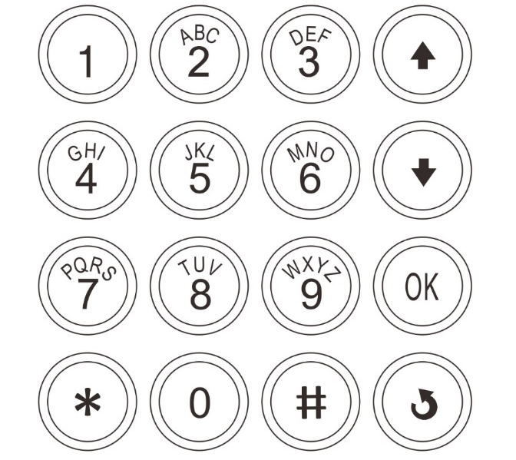
Volume Down
Volume Up
Card Recharge

3. Mounting the Phone
- Mount the Payphone on the wall by screws through the holes at the back casing of Payphone.
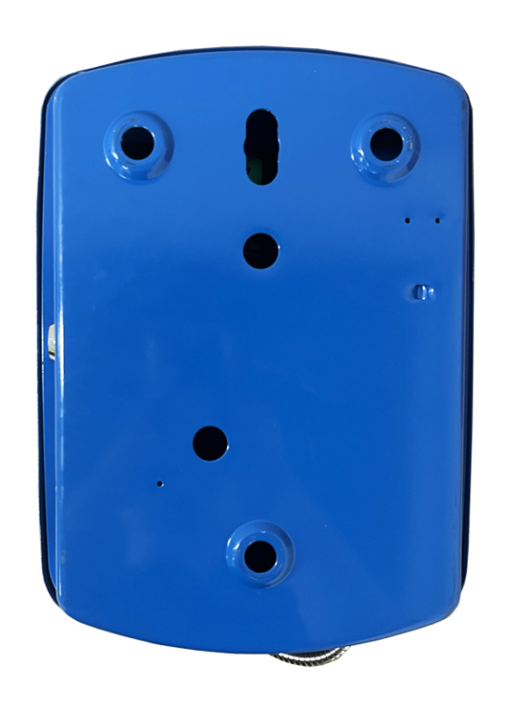
Hole for cables
- Open the door lock of Payphone via the key in the package. The main board will appear inside.
- Insert the 4G SIM card (Nano size) into the SIM Card Socket and push it until the SIM card is locked. (You can push the SIM card again to release it from the socket.)
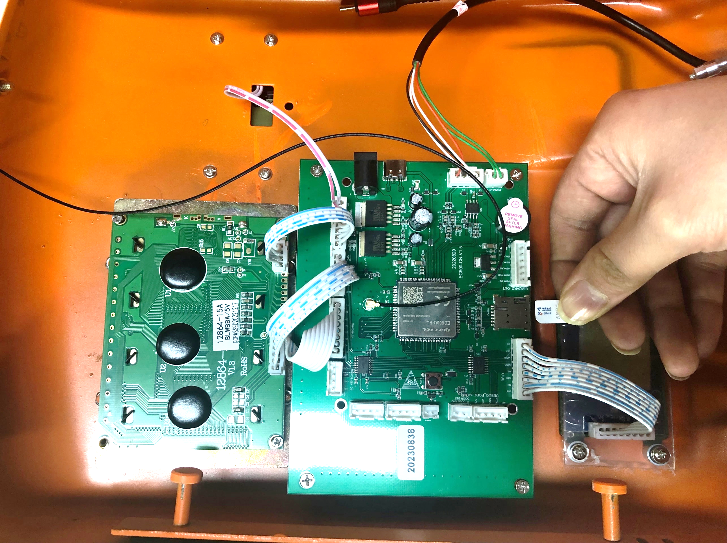

- Connect the 4G antenna with magnetic stand (with SMA connector) to the SMA-to-IPEX Jumper Cable inside the payphone (see figure below).
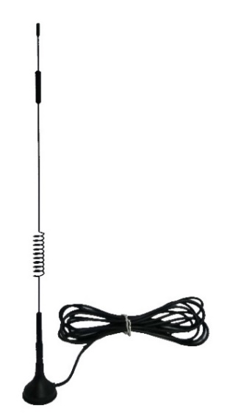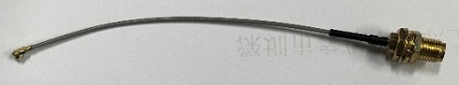 (SMA-to-IPEX Jumper Cable)

- Connect the Type-C connector of AC adapter to the Power Adaptor Socket (see figure below).
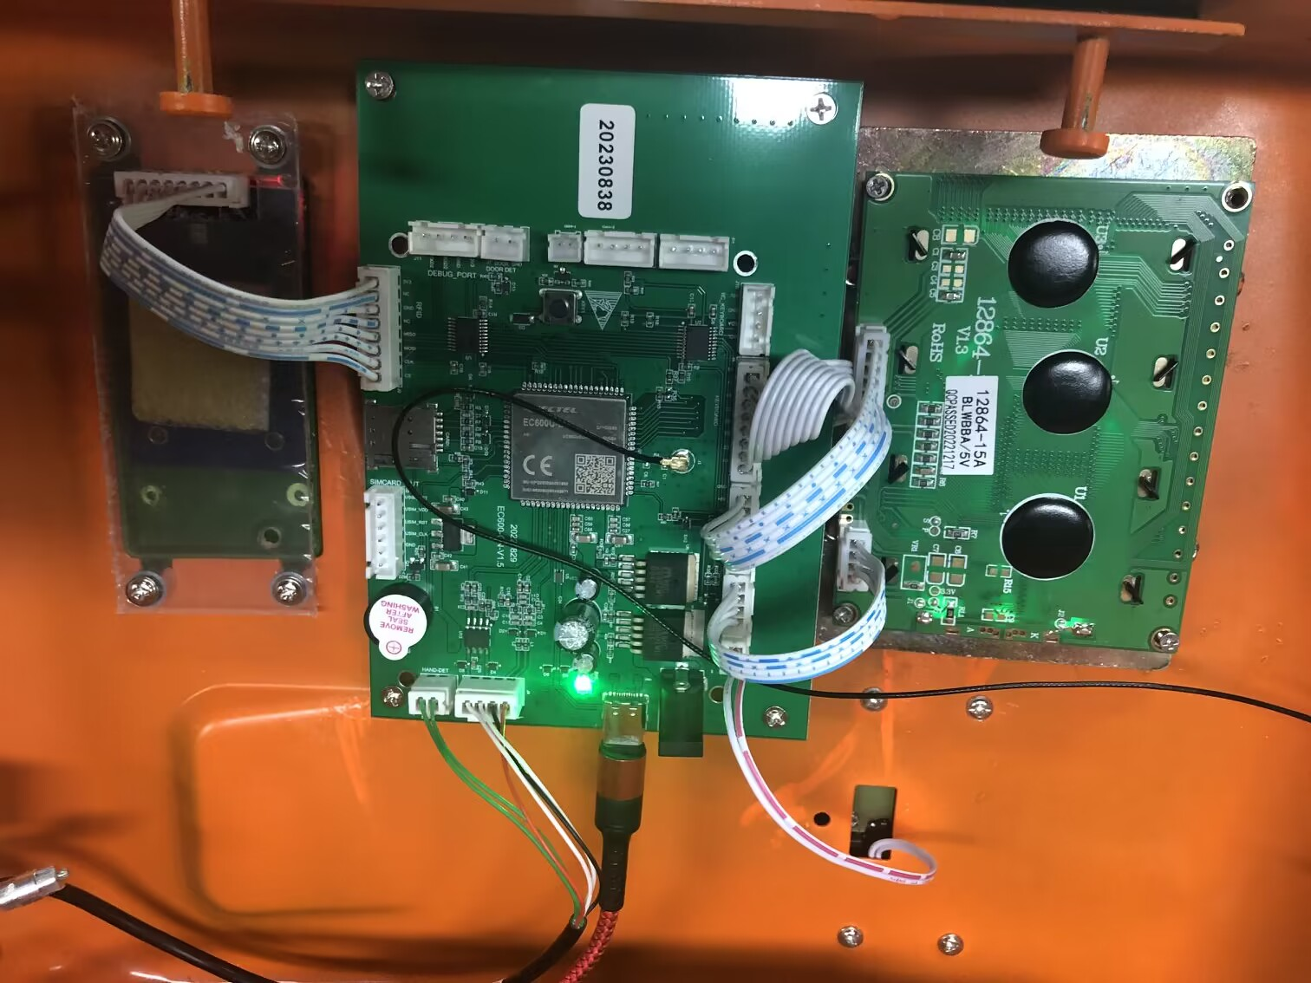
- Connect the AC adaptor to a main supply to switch on the Payphone.
- Wait for 1 minute around, then the screen will show the clock, operator name, and 4G signal strength. (The clock and operator name can be configured via the NMS.)

2 | 0 | 1 | 9 | - | 7 | - | 1 | 4 |  | 1 | 4 | : | 2 | 1
S | c | h | o | o | l |  | P | a | y | p | h | o | n | e
S | : | 2 | 6
Standby Display of Payphone
Operator Name (can be customized in the NMS)
Clock (date and time)
Signal Strength
- If the 4G connection fails, please do the following steps:
  - Power off the Payphone and then power it on again.
  - Please make sure that your 4G SIM card has enough balance of data and can access Internet by testing in your mobile phone.
  - Please check the 4G signal strength shown on the screen. Usually, it should be higher than 20.

4. Using the Phone
- Pick up the handset, a dialing tone will be heard. And the LCD will display like this:
P | L | E | A | S | E |  | T | A | P |  | C | A | R | D
P | L | E | A | S | E |  | D | I | A | L
- Place a valid RFID card on the card reader, the screen will display the credit of the card.
 |  |  |  |  | 1 | 2 | 1 | . | 5 | 2
P | L | E | A | S | E |  | D | I | A | L
- Dial the desired number and then the number will be sent out.
 |  |  |  |  | 1 | 2 | 1 | . | 5 | 2
0 | 7 | 5 | 5 | 6 | 5 | 2 | 0 | 6 | 8 | 8
D | i | a | l | i | n | g | . | . | .
- When the called party answers, the screen will dynamically display the remaining call duration at the first line and the current call duration at the last line.
 |  | 1 | 2 | : | 3 | 5 | : | 0 | 2
 |  |  |  |  | 1 | 2 | 1 | . | 5 | 2
0 | 7 | 5 | 5 | 6 | 5 | 2 | 0 | 6 | 8 | 8
 |  | 0 | 0 | : | 0 | 0 | : | 1 | 9
- Replace the handset to end the call or the call will be ended by the called party. The Payphone will beep and the screen will display the current balance of RFID card.
 |  |  |  |  | 1 | 1 | 0 | . | 0 | 4
B | y | e | - | b | y | e

Note: If the card is recognized as expired or invalid, the credit will be shown as 0 and then enter the card recharge process automatically.

5. Recharging a RFID Card
You need to firstly generate top-up voucher code in the NMS. Please refer to the Quick Start Guide of NMS for more details.
- Open a top-up voucher to check the top-up PIN.
- Place a valid RFID card on the card reader, the screen will display the credit of the card.
 |  |  |  |  |  | 0 | . | 0 | 2
P | L | E | A | S | E |  | D | I | A | L
- Press the [Card Recharge] button on the keypad. The screen will ask you to enter the top-up PIN.
 |  |  |  |  |  | 0 | . | 0 | 2
P | l | s |  | i | n | p | u | t |  | t | o | p | - | u | p
P | I | N | , | e | n | d |  | w | i | t | h |  | #
- Enter the top-up PIN printed on the voucher and press the [#] button.
 |  |  |  |  |  | 0 | . | 0 | 2
P | l | s |  | i | n | p | u | t |  | t | o | p | - | u | p
P | I | N | , | e | n | d |  | w | i | t | h |  | #
x | x | x | x | x | x
- If the card is successfully recharged, the screen will show the new card balance.
S | u | c | c | e | s | s | ! | T | h | e |  | n | e | w
b | a | l | a | n | c | e |  | i | s | :
 |  |  |  |  | 3 | 0 | . | 0 | 2
If failed, it will show like this:

E | X | P | I | R | E | D |  | V | O | U | C | H | E | R
R | e | c | h | a | r | g | e |  | F | a | i | l | e | d | !
or
I | N | V | A | L | I | D |  | V | O | U | C | H | E | R
R | e | c | h | a | r | g | e |  | F | a | i | l | e | d | !
or
V | O | U | C | H | E | R |  | B | A | L | A | N | C | E | 0
R | e | c | h | a | r | g | e |  | F | a | i | l | e | d | !

6. Make Call via “Collect-Call” Mode
In this mode, no RFID card is required.
- Pick up the handset, a dialing tone will be heard. And the LCD will display like this:
P | L | E | A | S | E |  | T | A | P |  | C | A | R | D
P | L | E | A | S | E |  | D | I | A | L
- Directly dial the desired number.
P | L | E | A | S | E |  | T | A | P |  | C | A | R | D
0 | 7 | 5 | 5 | 6 | 5 | 2 | 0 | 6 | 8
- If the dialed number has not been recharged before or it has zero credit, the screen will show like this:

 |  |  |  |  | 0 | . | 0 | 0
F | R | E | E |  | C | A | L | L |  | O | N | L | Y
- And wait for a while, the screen will automatically turn to the Interface to let you recharge the dialed number:
 |  |  |  |  | 0 | . | 0 | 0
P | l | s |  | i | n | p | u | t |  | t | o | p | - | u | p
P | I | N | , | e | n | d |  | w | i | t | h |  | #
- Enter the top-up PIN printed on the voucher and press the [#] button. It’s the same that, you need to firstly generate top-up voucher code in the NMS.
 |  |  |  |  |  | 0 | . | 0 | 0
P | l | s |  | i | n | p | u | t |  | t | o | p | - | u | p
P | I | N | , | e | n | d |  | w | i | t | h |  | #
x | x | x | x | x | x
- If the recharge is done, the screen will show the new balance for the dialed number.
S | u | c | c | e | s | s | ! | T | h | e |  | n | e | w
b | a | l | a | n | c | e |  | i | s | :
 |  |  |  |  | 3 | 0 | . | 0 | 2
- Then you can dial the number again when the screen shows like this:
 |  |  |  |  | 3 | 0 | . | 0 | 2
P | L | E | A | S | E |  | D | I | A | L

 |  |  |  |  | 3 | 0 | . | 0 | 2
0 | 7 | 5 | 5 | 6 | 5 | 2 | 0 | 6 | 8 | 8
D | i | a | l | i | n | g | . | . | .
- When the called party answers, the screen will dynamically display the remaining call duration at the first line and the current call duration at the last line.
 |  | 1 | 2 | : | 3 | 5 | : | 0 | 2
 |  |  |  |  | 3 | 0 | . | 0 | 2
0 | 7 | 5 | 5 | 6 | 5 | 2 | 0 | 6 | 8 | 8
 |  | 0 | 0 | : | 0 | 0 | : | 1 | 9
- Replace the handset to end the call or the call will be ended by the called party. The Payphone will beep and the screen will display the current balance of RFID card.
 |  |  |  |  | 1 | 0 | . | 0 | 2
B | y | e | - | b | y | e

7. Technical Specifications

Environmental Conditions | - Temperature: -10°C to 60°C (operation)  - Humidity: 10% ~ 95% non-condensing  - Atmosphere Pressure: 86 ~ 106 kPa
Power Requirement | - External adaptor (input: 100~240 VAC, 50/60 Hz / output: 12VDC, 1A)  - Power consumption: 6 watts  - Support solar power supply
Supported Network/Technology | - LTE FDD: B1/B3/B5/B7/B8/B20/B28  - LTE TDD: B38/B40/B41
Remote Management via NMS | - Configure call tariff rates  - Check revenue records of each payphone  - Supervise running status of each payphone  - Generate top-up voucher code to add balance on cards or recharge call cost for specified called number
Compatible Card | Mifare RFID card (13.56MHz)
Structural | - Housing Material: Power-coated steel (SECC)  - 4G Antenna: 1x 4G (external antenna with magnetic stand)  - 1x 4G SIM card slot  - LCD: 4-line, 128X64 pixels, backlight supported, shock resistance ≥ 4,000N  - Pull Resistance of Handset Cord: Not less than 150 kg  - Lifespan of Metallic Keypad: > 1,000,000 operations  - Dimensions: 350 mm x 230 mm x 175 mm  - Weight: 3.8 kg  - Packing Dimensions: 450mm X 400mm x 180mm  - Packing Weight: 4.55kg

8. After-Sale Service
Your satisfaction is our priority. Offering a quick and effective technical support, we always put the customer first. Please don’t hesitate to contact us by the following ways if you have any questions.

Shenzhen Guanri Netcom Technologies Co., Ltd.
Room 205-207, Building A, Xintiandi Industrial Park, Gushu,
Baoan District, Shenzhen 518126, P.R.China

Tel.: +86-755-86007778
https://www.wifibrother.com

